**MySQL + Info-Gathering:**

**CMF - MySQL Server Info-Gathering Automation for Windows - User Guide**

**For Script:**

**CMF-MySQL_WindowsServer_Info_Gathering.ps1**



**Document Summary**

|  |  |
| --- | --- |
| **Document Item** | **Current Value** |
| Document Title | CMF - MySQL Server Info-Gathering Automation for Windows - User Guide |
| Program | CSU Migration Factory |
| Date Last Modified | 25-Oct-2023 |
| Date Last Reviewed | 25-Oct-2023 |
| Current Document Known Issue | N/A |
| Status | Initial |
| Document Description | This document provides the procedure/steps to execute the Automation script which gathers the MySQL server details. |

**Revision History**

This section represents the change history of the document. Revisions of the document must be tracked by identifying a new version number, the date it was modified, the person making the change, and the reason for the change.

|  |  |  |  |  |
| --- | --- | --- | --- | --- |
| Date | Version | Change Description | Author | Reviewer |
| 25-Oct-2023 | 1.0 | Initial Version | Lekshmy, Arun, Mukesh, Chethan | Rackimuthu Kandaswamy |
| 02-Jan-2024 | 1.1 | Added SSL Mode | Chethan, Mukesh Lekshmy, Arun | Rackimuthu Kandaswamy, Sharad Khadtare |

Table of Contents

1. Executive Summary 4

1.1 Objective 4

2 Prerequisites for MySQL Server Info gathering - Execution 4

2.1 Non-Mission-Critical system 4

2.2 Operating System Requirements 4

2.3 Software requirements 4

2.4 Input Excel File 5

2.5 Windows User credentials 6

2.6 Storage Space & Folder read write permission. 6

2.7 Internet access: 6

2.8 Without Internet access to the URLs below 7

2.8.1 Installing Excel Import Module 7

2.9 PowerShell Version, Modules & Execution policy 10

2.10 Connectivity 11

3 Copying Script 11

3.1 Folder Name 11

3.2 Script and Input file 12

4 Executing the Script 13

4.1 MySQL Info Gathering execution 13

4.1.1 Open windows Command prompt as **Administrator** 13

4.2 CMF-MySQL_WindowsServer_Info_Gathering – script execution 14

4.2.1 Export Info-Gathering details and generating Excel Output files 16

# Executive Summary

## Objective

This document is to provide detailed procedure/step for fetching required below MySQL Information:

* Server Version
* Top 10 tables of the Databases
* Databases and Size details
* Current parameter setting details.

Note: This Automation Script does not fetch/access any of the user database data.

Note: The values present in the Screenshots are demo values. Please change the values as Appropriate.

# Prerequisites for MySQL Server Info gathering - Execution

## Non-Mission-Critical system

* **Don't install and run the Automation scripts on any mission-critical production server**

## Operating System Requirements

* Supported Operating System

Windows 10, Windows Server 2012, Windows Server 2012 R2 and above

## Software requirements

* MySQL Client 5.6 and above
* Windows PowerShell 4.0 and above.
  + Powershell Module(ImportExcel)

## Input Excel File

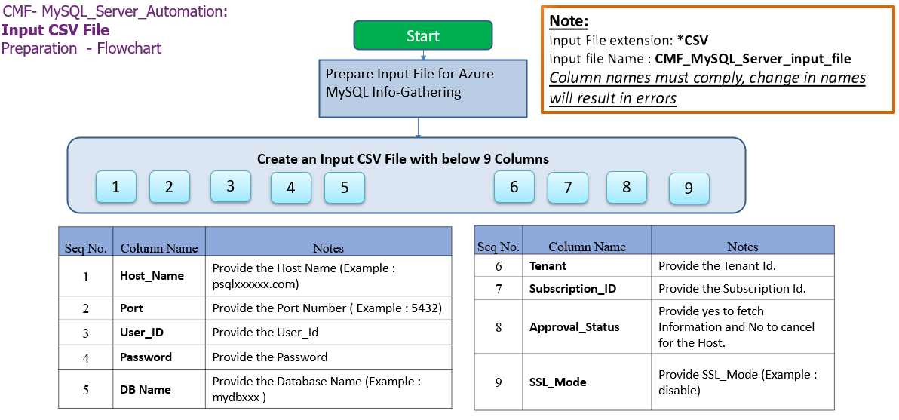

**Important Notes:**

* MySQL Client is required to establish Connectivity to MySQL Servers.
* This script is based on the CSV file named   
  ‘**CMF-MySQL_Server_Input_file.csv**’.
* **Column Name must be kept as shown below, change in names will result in errors**
* **Values in the column must be correct, incorrect values will also result in errors**
* **Tenant and Subscription_ID columns are Optional.**

1. **Columns for Input File: CMF-MySQL_Server_Input_file.csv**

|  |  |
| --- | --- |
| **Column Name** | **Note** |
| **Host_Name** | **Provide Host Name (Example: localhost)** |
| **Port** | **Provide Port Number (Example: 3306)** |
| **User_ID** | **Provide the User_ID** |
| **Password** | **Provide the Password** |
| **DB_Name** | **Provide Database Name (Example:mysqldb)** |
| **Tenant** | **Azure Subscription tenant ID (Optional)** |
| **Subscription_ID** | **Azure Subscription ID (Optional)** |
| **Approval Status** | **Provide YES to fetch the information and NO to exclude the host.** |
| **SSL_Mode** | **Provide SSL_Mode (Example : disable)** |

|  |  |  |
| --- | --- | --- |
| **Seq.No** | **File** | **Note** |
| 1 |  | Sample**: CMF-MySQL_Server_Input_file.csv** |

## Windows User credentials

Windows user must have privileges to install the following PowerShell modules:

* ImportExcel

## Storage Space & Folder read write permission.

* Windows user must have a privilege to create folder and write the assessment results to that folder
* Minimum disk free space required is 1GB

## Internet access:

* Connectivity must be available from the client to the Target Systems and Internet.

## Without Internet access to the URLs below

**Note:** Follow the instructions below to download all the software manually to a server where internet connectivity is enabled. Once all the software is downloaded, move all of them to the server where CMF - MySQL Server Info Gathering automation script will be executed and install all of them one by one.

### Installing Excel Import Module

1. Open Browser and navigate to the link <https://www.powershellgallery.com/packages/ImportExcel/7.4.1>
2. Click On Manual Download

1. Now Click on Download the raw nupkg file.
2. The file will be downloaded to Downloads folder

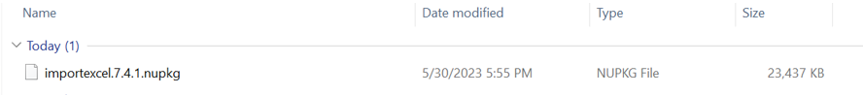

1. Right Click Properties-> and unblock the file -> Apply.

1. Rename the file as ImportExcel.zip.



1. Extract the zip RightClick-> Extract All

1. Goto Run Button -> Type Powershell and click on -> Windows PowerShell

1. Run the command. $env:PSModulePath which will list all the Environment variable paths for PowerShell Module



1. Navigate to the path which reflects with Program Files or ProgramFiles(X86) to the Respective modules Folder via FileExplorer and paste the extracted file (i.e. Step7)

Execute the below command from windows PowerShell as Administrator.

* **Import-Module ImportExcel**



## PowerShell Version, Modules & Execution policy

Execute the below commands from windows PowerShell as Administrator.

1. To find the PowerShell Version

* Get-Host

1. Set the PowerShell execution policy

* **Set-ExecutionPolicy Unrestricted -Scope CurrentUser**



## Connectivity

Connectivity must exist between the Jump Server and Target Systems.

# Copying Script

## Folder Name

* Login into a Non-Mission-Critical system (i.e.**NOT**on any production server) from where the MySQL Automation is to be run
* Create a folder C:\MySQL (you may choose any available drive)

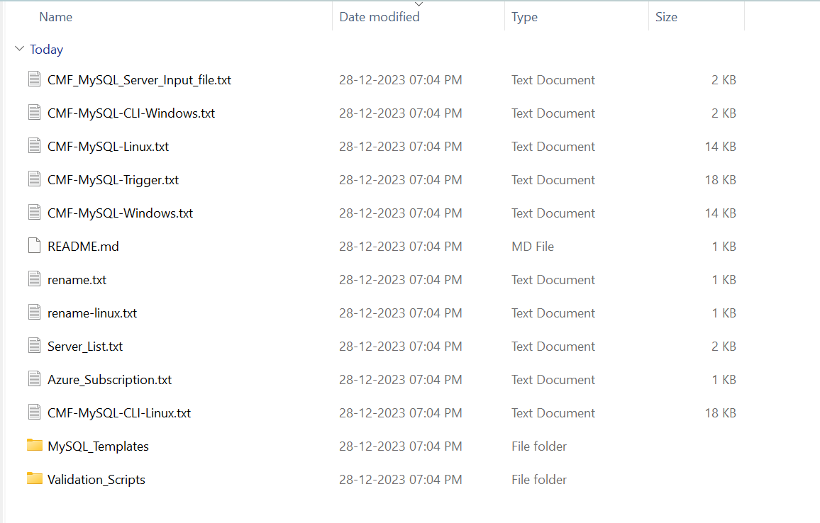

## Script and Input file

* Rename rename.txt rename.bat and run in info-gather folder

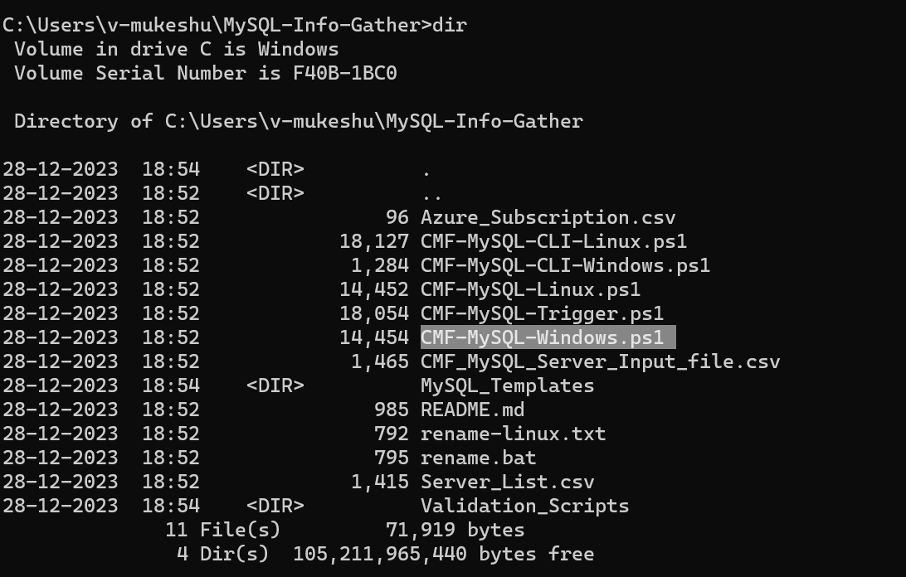

* Ensure the connectivity exists between the SYSTEM which runs the MySQL Info Gathering Automation script and MySQL Server.
* Once the input file is prepared Copy the file (**CMF-MySQL_Server_Input_file.csv**) under the folder created in the previous step (C:\MySQL)

# Executing the Script

## MySQL Info Gathering execution

### Open windows Command prompt as **Administrator**

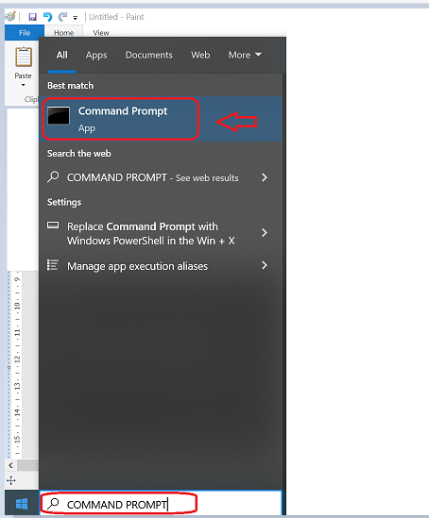

* Change the working directory/folder to the folder where you created/copied the script (CMF-MySQL_WindowsServer_Info_Gathering.ps1) in previous step
* Enter the following command at the windows command prompt.

**Powershell.exe -ExecutionPolicy RemoteSigned -File .\CMF-MySQL_WindowsServer_Info_Gathering.ps1**



## CMF-MySQL_WindowsServer_Info_Gathering – script execution

**Note:** After triggering the automation all the support folders(Output , Download etc. ) will be created automatically by the automation script, MySQL path is validated and it will ask user to proceed with the execution of the script

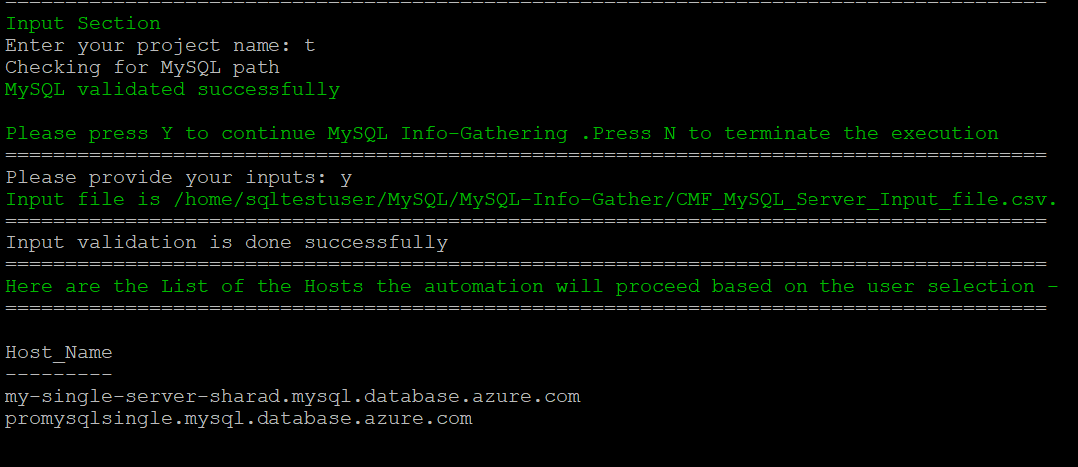

* The script then Validates the list of Hosts to proceed with execution. Continue by Entering “Y” and provide your Project Name. You’ll get below Final Status of the Script Execution.

Note: Ensure you add the location of Mysql.exe to your Path environment variables

* Please Enter “Y” to perform Info Gathering of Hosts above, otherwise Enter ‘N’ to terminate the execution.

### Export Info-Gathering details and generating Excel Output files

Note: The transcript log file can be found in Logs folder on the server where script is executed.

